Trabajo Práctico N° 4 | Energy Storage / Almacenamiento de Energía

TEXT A: Energy Storage — The Missing Link in the Renewable Revolution

Energy Storage: The Missing Link in the Renewable Revolution
One of the greatest challenges of renewable energy is its variability. The sun does not always shine, and the wind does not always blow. This means that solar panels and wind turbines often produce electricity at times when it is not needed, and produce little or no electricity at times of peak demand. Energy storage technologies bridge this gap.
The most widely used energy storage technology today is the lithium-ion battery, the same technology used in smartphones and electric vehicles. Utility-scale battery storage systems can store large amounts of electricity and release it to the grid when needed. Costs have fallen dramatically — by more than 90% over the past decade — making battery storage increasingly competitive.
However, lithium-ion batteries have limitations. They work best for short-duration storage (hours), and they require lithium, cobalt, and other materials whose extraction raises environmental and social concerns. Researchers are therefore exploring alternative battery chemistries, such as sodium-ion, iron-air, and flow batteries, which use more abundant and less problematic materials.
For longer-duration storage (days or weeks), other technologies are being developed. Pumped-storage hydropower — which pumps water uphill when electricity is cheap and releases it through turbines when electricity is needed — is currently the most widely deployed long-duration storage technology. Green hydrogen also offers long-duration storage potential: excess renewable electricity can be used to produce hydrogen, which can be stored and reconverted to electricity (or used directly) when needed.
The development of affordable and scalable energy storage is considered one of the most important technological challenges of the 21st century. Solving it will be essential for building a fully renewable energy system.
Source: Adapted from IEA, NREL and MIT Energy Initiative reports (educational use)
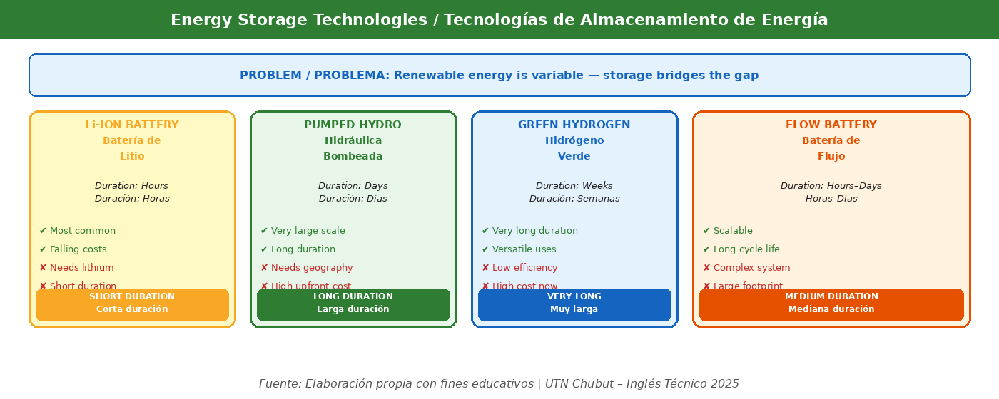
Fig. 5 — Energy Storage Technologies / Tecnologías de Almacenamiento

A. SKIMMING
Responde sin leer el texto en detalle.

- ¿Cuál es el tema principal del texto?
- ¿Cuántos párrafos tiene? ¿De qué trata cada uno?
- ¿Qué tecnología de almacenamiento menciona el título implícitamente?

B. SCANNING — RESPONDE EN ESPAÑOL
Lee el texto con atención y responde las preguntas.

- ¿Por qué el almacenamiento de energía es necesario para las energías renovables?
- ¿Qué es una batería de iones de litio y dónde se usa actualmente?
- ¿Cuánto han caído los costos de las baterías en la última década?
- ¿Cuáles son las limitaciones de las baterías de litio?
- ¿Qué alternativas se están investigando?
- ¿Cómo funciona el almacenamiento hidráulico por bombeo?
- ¿Por qué el hidrógeno verde también puede ser una solución de almacenamiento?

C. REFERENCE
¿A qué se refieren las siguientes palabras?

1. it (párrafo 1: "it is not needed ") → ¿A qué se refiere?
2. they (párrafo 3: "they work best") → ¿A qué se refiere?
3. which (párrafo 4: "which pumps water uphill...") → ¿A qué se refiere?
4. it (párrafo 5: "it will be essential...") → ¿A qué se refiere?

D. CONTEXTUAL GRAMMAR — CONECTORES
Los conectores expresan relaciones lógicas entre ideas:
HOWEVER: contraste. Ej.: Batteries are useful. However, they have limitations.
THEREFORE: consecuencia. Ej.: Costs fell; therefore, adoption increased.
ALTHOUGH: contraste en la misma oración. Ej.: Although wind is variable, it is clean.
BECAUSE: causa. Ej.: Storage is needed because the sun does not always shine.
SUCH AS: ejemplo. Ej.: Alternative batteries, such as sodium-ion, are being developed.

Analiza las diferencias de significado entre estos pares de oraciones:
- (a) Batteries are cheap. However, they have limitations.
- (b) Batteries are cheap because costs have fallen dramatically.
- (c) Although batteries are useful, they have limitations.

Completa las oraciones con el conector adecuado (although / however / therefore / because):
- Wind is clean energy. __________, it is variable.
- Solar panels are efficient __________ they convert sunlight directly into electricity.
- __________ green hydrogen is expensive, it has great potential.
- Costs are falling; __________, adoption is increasing.

E. TRADUCCIÓN AL ESPAÑOL
Traduce este párrafo al español. Presta atención a los conectores.
The most widely used energy storage technology today is the lithium-ion battery, the same technology used in smartphones and electric vehicles. Costs have fallen dramatically — by more than 90% over the past decade — making battery storage increasingly competitive. However, lithium-ion batteries have limitations. They work best for short-duration storage, and they require lithium and other materials whose extraction raises environmental concerns.

Tu traducción al español:

